Eloise Mildenhall
Word Count: 1528
Critical Reflection
Assessment 2 – TIMS3311
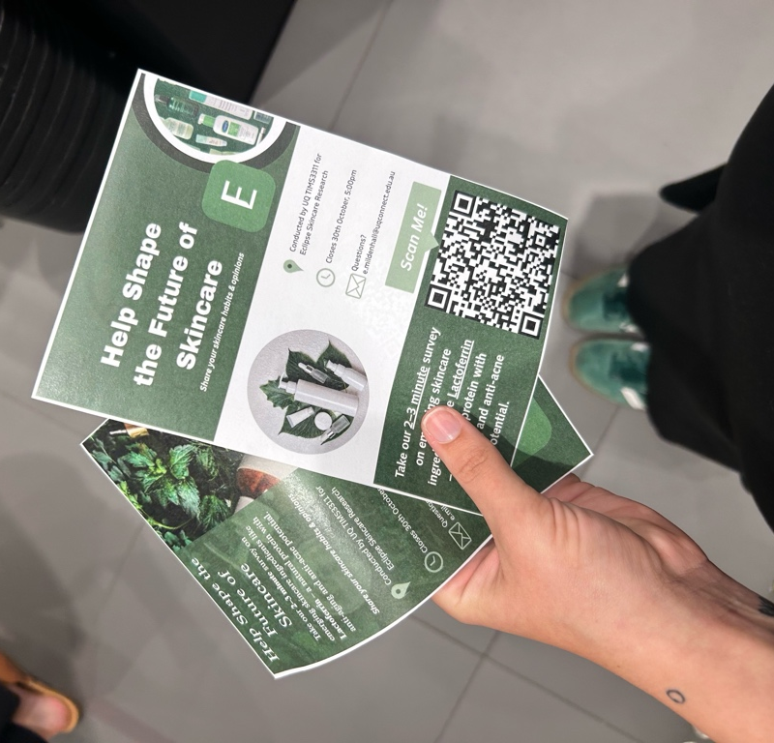
Introduction
The Work Integrated Learning (WIL) experience in TIMS3311 was one of the most practical and engaging parts of my degree. My group partnered with Eclipse, a biotechnology company led by CEO Siobhan, who tasked us with exploring how Lactoferrin, a natural protein with antibacterial and anti-inflammatory properties, could be incorporated into skincare products. This project gave me the opportunity to combine creativity, research and consumer insight to help a real company explore a new market. Throughout the project, I developed stronger research, communication and problem-solving skills and gained confidence in applying entrepreneurial thinking to real-world challenges. Beyond the tasks, the WIL experience also taught me a lot about myself, teamwork and what it is like to work in a startup.

Overall WIL Experience
Through the WIL experience, I learned a lot about how I work best and what motivates me. I discovered that I like to take the lead on assignments and work best when there are clear deadlines and structure. I find it harder when tasks are undefined, so this experience taught me how to organise my work more effectively using weekly plans, to-do lists and role tables to keep myself and my team on track. I also realised how much I enjoy brainstorming with others. Working with my friends Paige, Bella, Ruby and Crystal-Rose made collaboration feel natural and sharing ideas together helped spark creativity and motivation.
One of the biggest personal lessons I learned was how to handle negative feedback. In the past, I found criticism hard to take, but during the WIL I came to appreciate it as a chance to learn and improve. When Jack suggested adding product mock-ups to the survey and removing some of the questions, I was actually very appreciative of his feedback. Instead of feeling defensive, I saw it as extremely helpful and constructive as it made our survey clearer and more engaging. Because I was working with friends, receiving feedback felt supportive rather than discouraging and it helped me refine my ideas and grow more confident in my work. Positive feedback from Siobhan also gave me a real sense of accomplishment.
I faced some challenges too. Balancing WIL tasks with my university workload and working full time required careful time management. Learning new tools like survey platforms were stressful at times. Disagreements in the team about design choices, tested my ability to listen, compromise and find solutions. Working with a startup was also unpredictable, to manage this I focused on listening actively every weekly catchup, taking notes to summarise to the group to make sure everyone was aligned and staying flexible and patient in a changing environment.
Looking back, I would have asked for feedback on the groups work and communication earlier. Overall, the WIL experience was one of the most valuable parts of my degree. It taught me how to lead with structure, collaborate with empathy and adapt to real-world challenges. It also gave me confidence in my ability to work professionally within a startup environment and reinforced how I enjoy creative, hands-on problem-solving.

Networks Established
My team was made up of my friends Paige, Bella, Ruby and Crystal-Rose, which made working together enjoyable and comfortable. We already had a strong sense of trust and communication, which helped us collaborate effectively throughout the project. Through the WIL experience, we also connected with Siobhan, the CEO of Eclipse, the startup we partnered with. Speaking with her gave us valuable insight into how a small biotechnology company operates and how leadership and innovation work in real-world settings. Networking through meetings helped me understand how startups work, and the skills needed to succeed. Building this connection allowed us to see how professional networks can open opportunities for learning and future collaboration. Overall, I gained a better understanding of the value of teamwork and how forming relationships can enhance both personal and professional growth.

Knowledge, Insights and Skills Gained
Before WIL
Before WIL, I had limited practical experience in entrepreneurship. I understood basic concepts like Lean Startup, MVP design and Stakeholder Mapping but I had not applied them in real situations. Previously, I had worked on academic projects where we had to create business ideas and presented them to peers, but I had not worked with a real CEO or business to test ideas. My teamwork experience was mostly in structure academic environments.

During WIL
Entrepreneurial Concepts
During this journey, I learned how to apply Lean Startup principles, including making prototypes and testing ideas quickly. I also learned how important it is to get feedback from consumers and adjust based on what they say. I gained experience in business modelling and designing value propositions, which helped me understand how to align ideas with market needs.

Practical Skills
Throughout the WIL experience, I developed a range of practical and entrepreneurial skills that I can carry into my future career. I learned how to create and refine product mock-ups, surveys and how to apply frameworks like the Business Model Canvas (BMC and empathy mapping to real-world companies and situations. Using the BMC helped me break down Eclipse’s value proposition, customer segments and revenue streams, giving me a clearer understanding of how all parts of a business connect strategically. Empathy mapping, on the other hand, helped our team think from the consumer’s perspective which directly informed our product design and decisions.
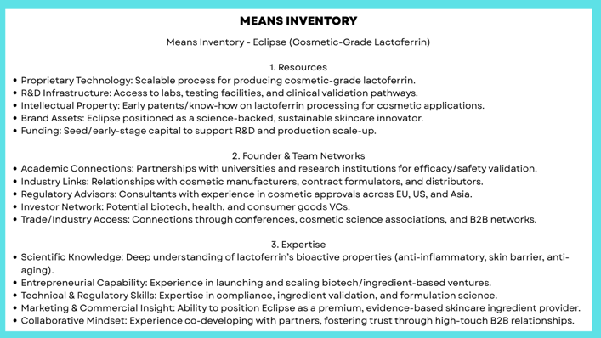
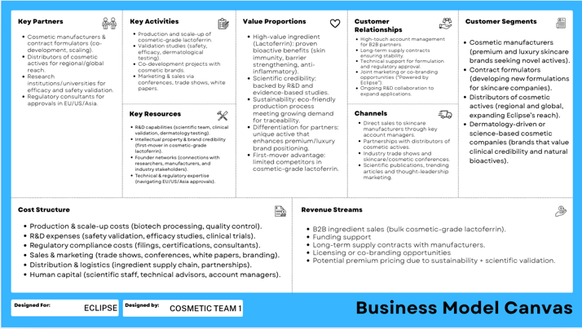
Working within a dynamic and motivated team further helped me develop essential collaboration and conflict resolution skills. When our group had different opinions about product direction or design, I learned to actively listen, facilitate discussion and find compromises that suited both creative and practical goals. This experience improved my emotional intelligence and leadership ability – skills that are crucial for an entrepreneurial or innovation-focused career. Learning how to clearly explain ideas, justify decisions and respond to feedback helped me build professional confidence and taught me how to engage effectively.

Insights
A key insight I gained was that innovation requires flexibility and adaptability. Not every idea works out as planned. For example, we initially considered a lactoferrin-based cleanser, but this wasn’t feasible because Lactoferrin needs to remain on the skin for a prolonged time to be effective. This experience showed me that entrepreneurship is about experimentation and knowing when to pivot. Reflecting ideas from lean startup and effectuation theory.
I also learned that risk-taking and experimentation are essential for innovation. Through testing designs, adjusting surveys and refining our marketing approach, I saw how valuable feedback loops are for improvement. This taught me to see mistake not as failures but as opportunities to learn and adapt.
These lessons will strongly influence my future career. Whether in innovation, marketing or product development, I now feel more confident in leading projects, staying adaptable and solving problems creatively.

Future Application
The skills and knowledge I gained will help me in future projects or careers in entrepreneurship and innovation. I am more confident in managing projects, working with diverse teams and adjusting ideas based on feedback. I have improved my ability to present ideas and will carry forward lessons about flexibility, risk-taking and balancing creativity with practical needs in any future work.

Value and Suggestions
I valued being able to learn in class to real-world startup. Mentorship from Siobhan was an extremely helpful jumpstart into what it takes to strive in a real-world startup. I also appreciated learning about the challenges and problem-solving skills that it takes. My communication, teamwork and adaptability skills grew a lot during this WIL experience.

Suggestions for Improvement
While the WIL experience was highly valuable, there are a few ways it could be improved to support students further. One improvement could be introducing a mid-way feedback form for students. This would not be graded but would provide an opportunity for students to share their progress, challenges or any concerns directly with the teaching team before the final stages of the placement. Also, it would be a good option for students who may not feel comfortable joining a call with Jack, as my group did a few times. This would help ensure that all students receive the right level of support, even if they prefer to communicate in writing.
Another helpful addition would be making the reflective diary entries a weekly submission rather than all at once at the end. Since this assessment already requires 5 diary entries, submitting them progressively would allow the teach to follow along with each students journey and provide feedback in real time. This would encourage students to regularly assess what they are learning and how they are developing key skills such as teamwork, communication and problem solving. Having a structured way to track growth throughout the experience would make it easier to identify personal strengths and areas for improvement. Overall, these small adjustments could help the WIL experience even more engaging, reflective and supportive for future students.

Conclusion
The TIMS3311 WIL Experience was both challenging and rewarding. I learned more about myself, my strengths and areas I can improve. I gained practical skills in research, innovation, teamwork and communication. The experience also showed me what working in a startup in really like, including its challenges and opportunities. The lessons I learned, the skills I developed and the networks I built will help me in future projects, jobs and career decisions in innovation and entrepreneurship.

Reflective Diary Entry 1 - Designing and Conducting Interviews
At the beginning of our WIL project, my group met with Siobhan to plan our research approach and agreed to focus on three key groups – women aged 16+, men aged 20+ and beauty retail staff. Since interviewing is not one of my strongest skills, I volunteered to take the lead on writing the interview questions. I wrote these questions, focusing on skincare habits, product perceptions and attitudes toward natural or science-backed ingredients. After refining the questions from receiving feedback from Siobhan and my teammates, I divided the interviews based on demographic focus.
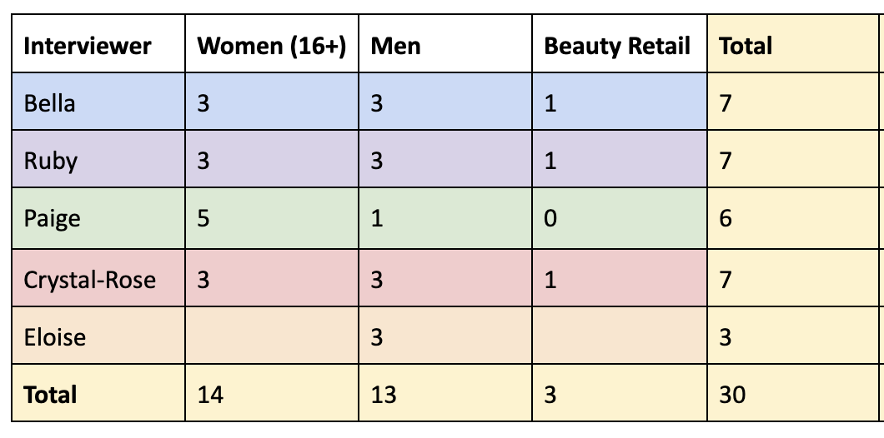

I conducted three male interviews: Caige (21), a fourth-year electrical apprentice; Dylan (25), a university student; and Wayne (62), a General Manager at Fort Vale Australia. They each offered unique perspectives shaped by age and lifestyle. Caige valued convivence and price showing little interest in skincare beyond basic hygiene. Dylan relied on his partner’s choices but was open to natural, effective ingredients like lactoferrin. Wayne viewed skincare as feminine and time-consuming, preferring simplicity for practical reasons. These interviews improved my confidence and revealed that most men prioritise ease, functionality and credibility over luxury in skincare. This understanding will directly inform how our team develops recommendations for positioning new ingredients like lactoferrin in skincare products. Overall, this process strengthens my skills in question design, communication and consumer insight generation and helped me grow more confident in applying research methods within a real-world business context.

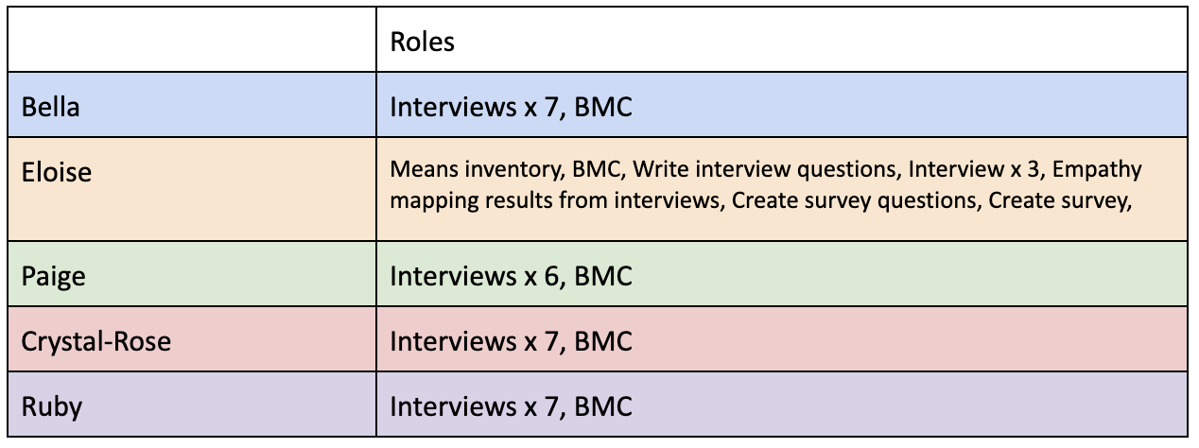
Reflective Diary Entry 2 - Empathy Mapping
During the mid-semester break, from 29 September to 5 October, I independently completed the empathy mapping stage of our project. Before starting, I used IDEO’s guide “Build Your Creative Confidence: Empathy Maps” (Kelley, 2018) to understand how to structure qualitative data through the “say, do, think, feel” framework, followed by identifying pains and gains. This method helped me analyse the interviews systematically and avoid being overwhelmed by information.
I created empathy maps for each demographic. Women valued gentleness, ingredient transparency and authenticity, often guided by social media recommendations. Men prioritised simplicity, low effort and affordability with many seeing skincare as optional or partner driven. Beauty retail staff highlighted education and clear ingredient communication as crucial for consumer trust.
Working through this process taught me how to translate raw interview data into meaningful insights and notice behavioural patterns across demographics. It also strengthened my confidence in qualitative analysis, empathy-based research and independent problem-solving. Overall, applying IDEO’s method improve both the quality of our findings and my ability to think critically and creatively about user experiences.

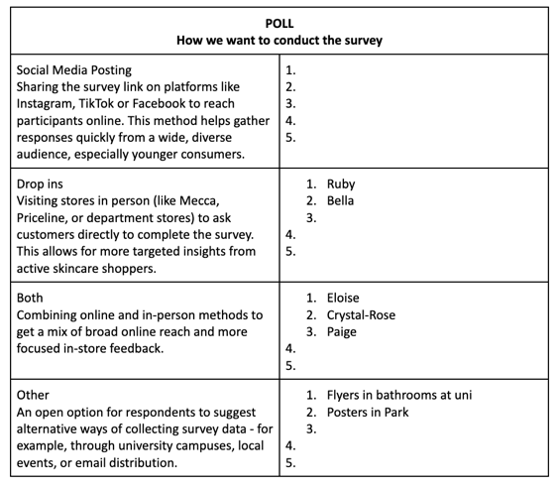
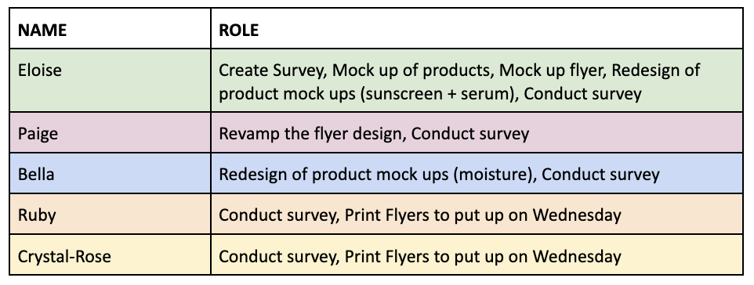
Reflective Diary Entry 3 - Survey Questions + Product Mock Ups

For this stage of the project, I worked on refining our consumer survey and developing visual mock-ups for the skincare products. Bella and I met with Jack, who provided feedback that our original survey draft had too many questions, which could discourage responses. Based on his advice, we shortened and simplified the survey to make it more engaging and user-friendly. To help participants visualise product options, I created mock-ups for sunscreen and serum, while Bella designed moisturiser mock-ups for each product category: science-backed, natural and organic and luxury and lifestyle. I also created a poll in our shared Google Doc to decide as a team how we could want to conduct the survey – whether through social media, in store drop ins or a combination of both. After discussing, most of us agreed that combining online and in-person approaches would help capture a wider range of responses. Additionally, I drafted a flyer to promote the survey around campus, which Paige later redesigned into two polished final versions that looked amazing. This process helped me understand how to balance feedback, collaboration and design thinking to create effective research materials that attract participants and generate quality insights.



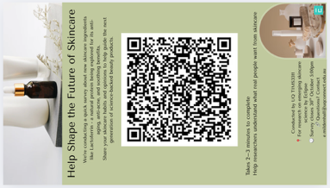

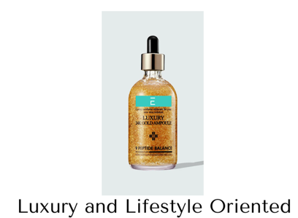




Reflective Diary Entry 4 - Creating Survey
Initially, I created the survey using SurveyMonkey, as it seemed like a simple and accessible tool for gathering responses. However, after developing the draft, I quickly realised that SurveyMonkey required a paid subscription to access essential features. It also didn’t look very professional, which was not ideal for a university project. I wanted the survey to appear clear, trustworthy and well-presented so that people would take it seriously and give thoughtful answers.
After talking with my group, I decided to switch to Qualtrics instead. This platform was available through University of Queensland and didn’t cost anything to use. It looked much more professional and included the UQ banner, which made it appear official and academic. I also found Qualtrics much easier to use and customise. It allowed me to design the layout and include the project mock-ups we created for the sunscreen, serum and moisturiser options.
Using Qualtrics made the survey looked cleaner and easier to complete, which should help us get better-quality responses. Overall, this experience taught me how important it is to choose the right tool when creating surveys. A good platform can make the process faster, look more professional and encourage more reliable responses. In the future, I will definitely use Qualtrics again for research projects because it is simple, effective and gives a much better impression that other free tools.

Reflective Diary Entry 5 - Conducting Survey
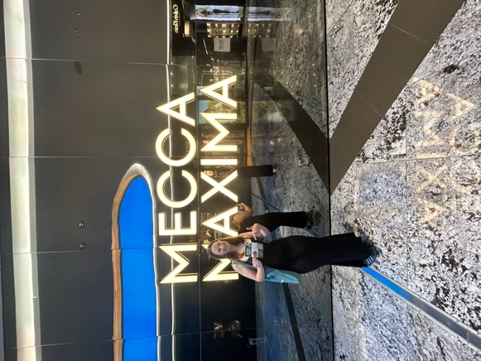
On Friday, the 10th of October, we received confirmation from Siobhan that our survey looked great but needed a few small changes. I made these adjustments right now to finalise the survey before sharing it. Once it was ready, I sent the link to my family and friends over Friday and Saturday to start collecting responses.
On Sunday, the 12th of October, Paige and I went to Indooroopilly Shopping Centre to conduct in-person surveys. We visited Mecca, Sephora and the Body Shop to speak directly with shoppers and the employees. Our goal was to get honest opinions and insights from people who are familiar with skincare products. Throughout the day, we managed to get 10 participants to stop, chat with us and complete the survey.
The experience was really positive and gave us useful feedback. At Mecca, several employees recommended the brand Dr. Jart, saying it is very well-known and extremely effective. All the staff spoke very highly of its products, which helped us understand what customers and beauty professionals value in skincare.
Conducting the survey in person helped us engage with people more meaningfully and gather richer insights than we could have online alone. It also gave us more confidence in our project, as we saw genuine interest from shoppers and staff. Overall, this experience taught me how valuable face-to-face engagement can be when gathering real-world feedback for research projects
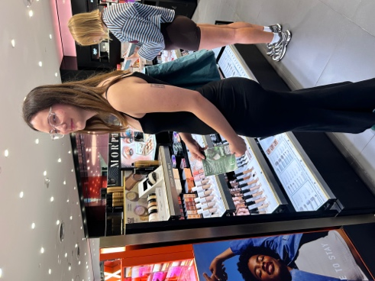
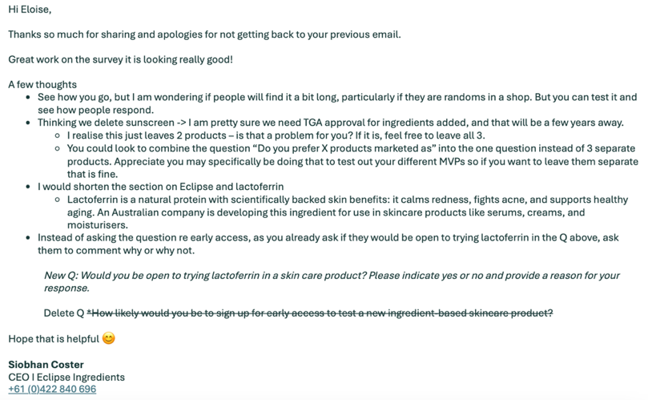
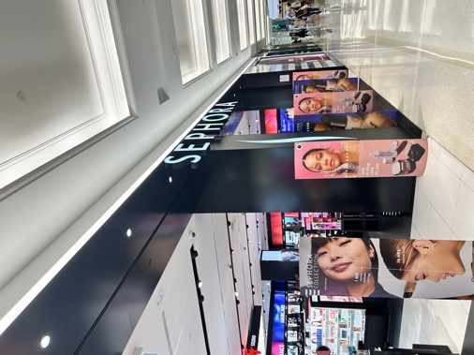
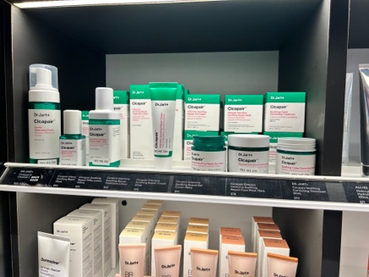
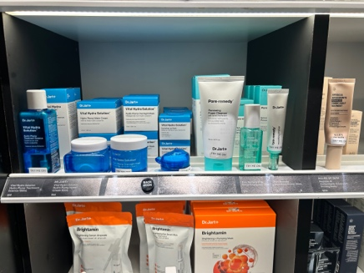
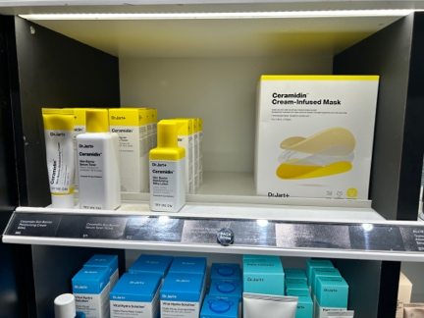

Reference list
Andrews, J. (2025). Innovation and Entrepreneurship in Practice (St Lucia). Semester 2, 2025 TIMS3311_7560_60465 [Review of Innovation and Entrepreneurship in Practice (St Lucia). Semester 2, 2025 TIMS3311_7560_60465]. Blackboard; University of Queensland. https://learn.uq.edu.au/ultra/courses/_192204_1/cl/outline
Lecture Material Weeks 1 - 12
Kelley, T. (2018, November). Build Your Creative Confidence: Empathy Maps. IDEO. https://www.ideo.com/journal/build-your-creative-confidence-empathy-maps
Manfield, R. (2025). Entrepreneurial Growth Strategies (St Lucia). Semester 1, 2025 TIMS3302_7520_20091 [Review of Entrepreneurial Growth Strategies (St Lucia). Semester 1, 2025 TIMS3302_7520_20091]. Blackboard; University of Queensland. https://learn.uq.edu.au/ultra/courses/_185592_1/cl/outline
Lecture Material Weeks 1 - 12
Newey, L., & Tugei, G. (2025). Transformative Innovation for 21st Century Challenges (St Lucia). Semester 2, 2025 TIMS3310_7560_60222 [Review of Transformative Innovation for 21st Century Challenges (St Lucia). Semester 2, 2025 TIMS3310_7560_60222]. Blackboard; University of Queensland. https://learn.uq.edu.au/ultra/courses/_191967_1/cl/outline
Lecture Material Weeks 1 - 12
Zankl, J. (2025). Social Entrepreneurship (St Lucia). Semester 1, 2025 [Review of Social Entrepreneurship (St Lucia). Semester 1, 2025]. Blackboard; University of Queensland. https://learn.uq.edu.au/ultra/courses/_185593_1/outline
Lecture Material Weeks 1 - 12

